**Spike:** 16

**Title:** Sprites & Graphics

**Author:** Parth Madhani, 101901858

**Goals / deliverables:**

* Code
* Show/program how to load and display multiple images, including sub-regions of one image onto another using SDL2 for presenting images and sub-regions of regions.

**Technologies, Tools, and Resources used:**

* Visual Studio IDE
* Assorted web sources.
  + YouTube
  + Tutorials

**Tasks undertaken:**

* Research SDL2 framework and how to implement images with it.

Implement the code and design the layout for the image.

* Testing code to ensure it all works the same as before.

**What we found out:**

We found out how to use SDL2 to display images using texture based. I used a file named images.png which had sprites in it which I divided into 3 tiles for now with just the top 3 images on y axis being used as an example for this program. First I loaded the images and background to a texture and rendered it later when the user pressed 1,2,3 or 0 keys respectively. This was fairly easy to perform as rendering takes less time.

My image file I used for dividing

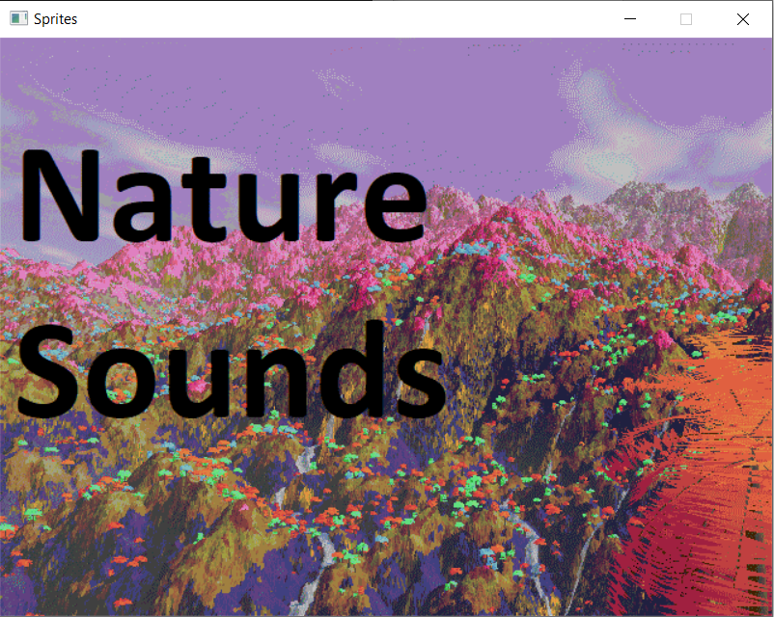

Output with my background loaded which can be toogled by pressing 0

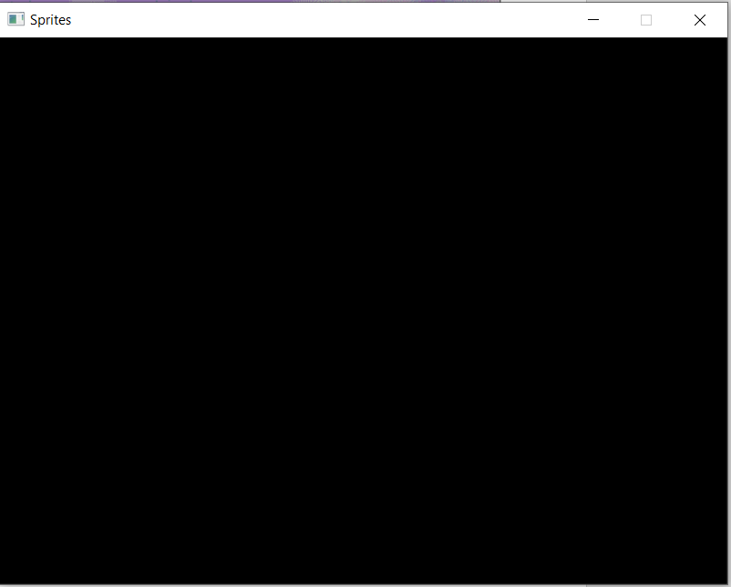

Output when pressed 0 – background goes black

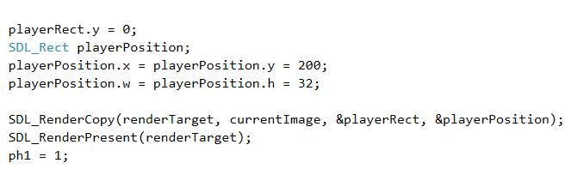

Basic code for dividing and loading tile at position 200,200 in this case

Similar code follows for other two tiles but with position differing to another location as it makes it easier.

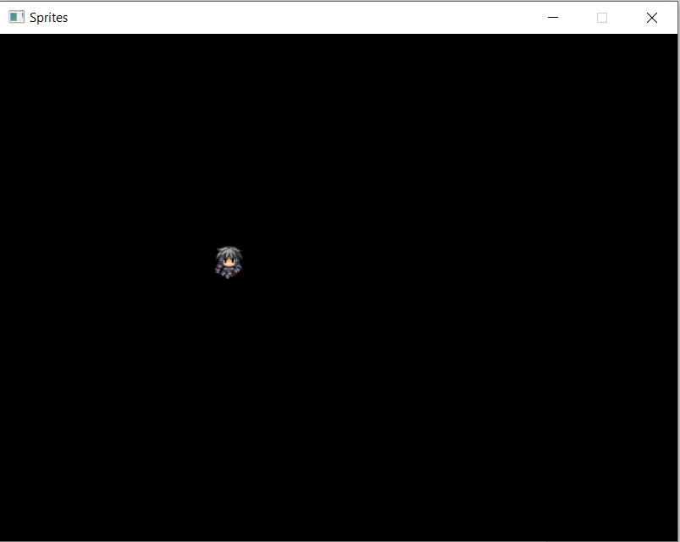 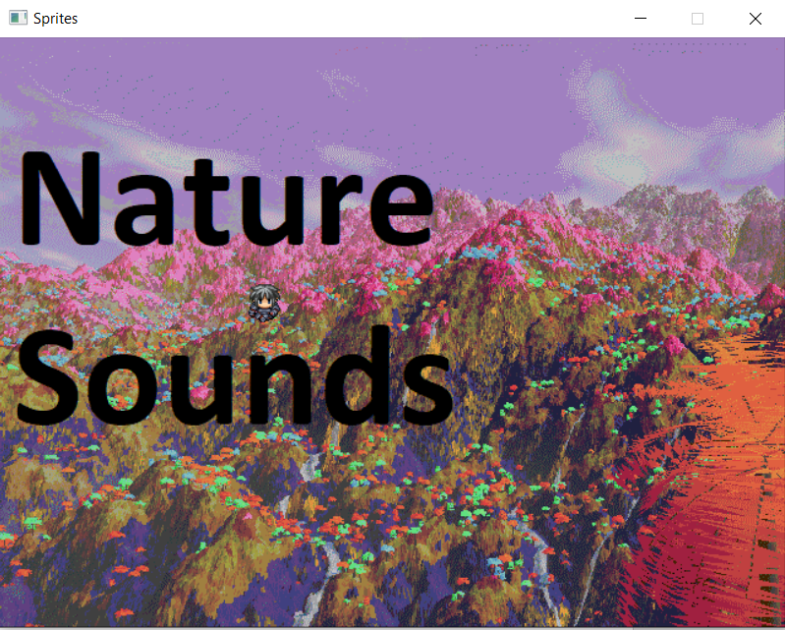

Sprite 1 divided and loaded Sprite 1 loaded with background

when background is off toogled ‘on’ with 0 key.

Sprite1 can be toogled on and off using 1 key. For sprite 2 similar code follows:

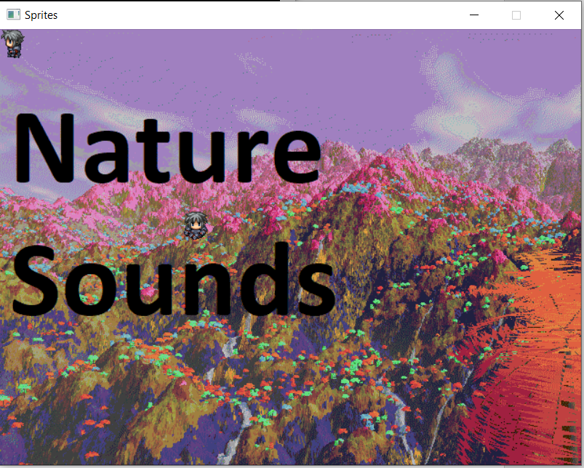 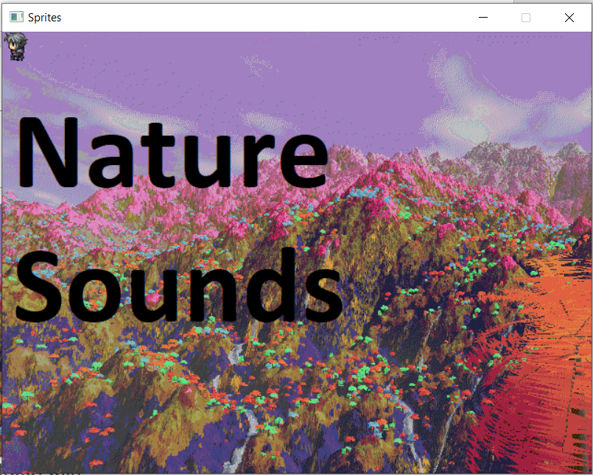

Sprite 2 loaded on top left(0,0) with Sprite 2 loaded with sprite 1

background on toogled off

Sprite 2 can be toogled on or off using 2 key. Similar code follows for sprite 3. After setting up code we display sprite using 3 key which is used for toogling it on or off.

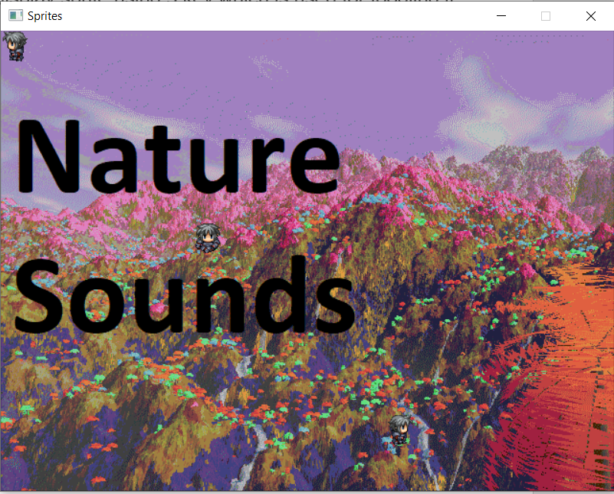 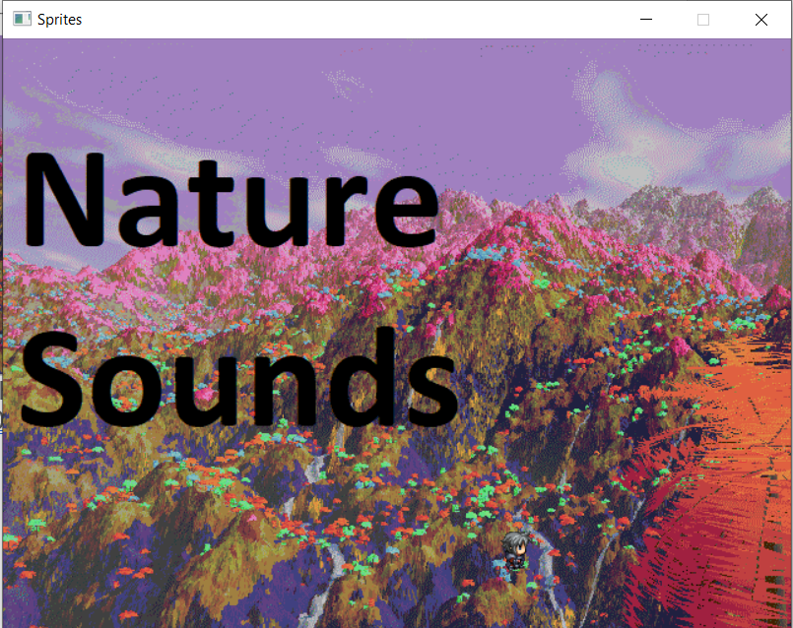

All 3 sprites turned on with sprite 3 Sprite 1 and 2 toogled off just

On bottom right ( 400,400) sprite 3 is on.

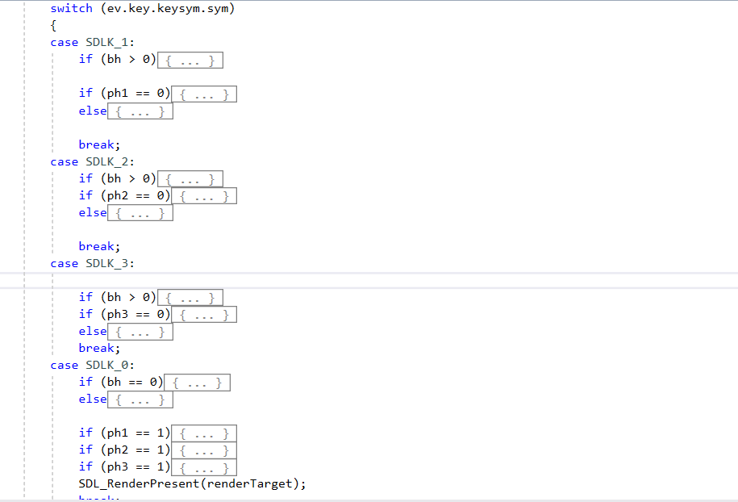

Basic layout of code used for rendering the details.

In the above code bh is check I used for checking for background image while ph1 is check I used for sprite 1 similarly ph2 for sprite 2 and ph3 for sprite 3 which makes it easy for us to identify if particular sprite is on or off.